Sailing Slow Solar Winds: New View from the Far Side of the Universe

(Title is in 18 point Times Roman font, cap/lower case, single-spaced, bold, and centered)
Gary M. Larson*, Georgios N. Ikaros†,
and O. Susanne Hiquu¶
(Authors are in 13 point Times Roman font, cap/lower case, centered)
*Laboratory for Astronomy and Solar Physics, NASA Goddard Space Flight Center, Greenbelt, MD 20771, USA
†Department of Physics, National Technical University, GR-10101 Athens, Greece
¶Department of Astronomy, Yale University, P.O. Box 208101, New Haven, CT 06520-8101, USA
(Addresses are in 10 point Times Roman font, cap/lower case, italic, centered; use complete addresses)

The trim size of the conference proceedings is 6 3/8 x 9 . inches (162 x 235 mm). The text area on the page will be 5 13/16 inches wide by 8 5/8 inches long (148 mm x 219 mm or 35 x 52 picas). It is important to follow the specifications exactly when setting the margins. You may have to compute the margin settings and test them to make sure the text area dimensions are followed exactly. All pages will be reduced 15% during the printing process, so the text area noted above as well as the instructions on font sizes to be used must be followed exactly. Embed all fonts when saving your file.
Times Roman font is used throughout the paper with single line spacing and the text is fully justified. Paragraph style: indent first line three spaces (0.19 inches), no extra line spacing between paragraphs. Please use 11 point font for text. Avoid large blank areas within the text area and do not type outside the text area. Do not include any headers or footers in your document.
Figures, tables, and equations must be inserted in the text and may not be grouped at the end of the paper. Important: miscounting of figures, tables, or equations may result from revisions. Please double check the numbering of these elements before you submit your paper to the volume editor.
Cite all figures in the text consecutively. The word “Figure” should be spelled out if it is the first word of the sentence and abbreviated as “Fig.” elsewhere in the text. Place the figures as close as possible to their first mention in the text at the top or bottom of the page with the figure caption positioned below, all centered. Figures must be inserted in the text and may not follow the Reference section. Set figure captions in 10 point size, Times Roman font. Type the word “FIGURE 1.” in bold all caps, followed by a period. Each figure must include a caption. The caption should be the full width of the text area; if the caption runs shorter than the width, center the caption.

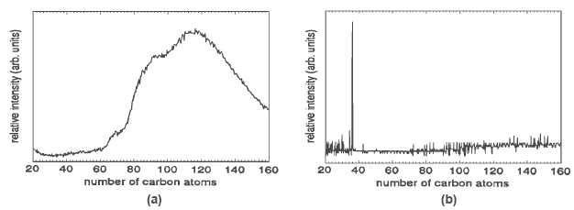
FIGURE 1. Use 10 point font size for figure captions. Figures must be inserted in the text and may not
follow the Reference section.
Provide black-and-white figures if they should be printed in black-and-white. Figure 1 is an example of a black-and-white line drawing. Some color figures can be printed in black-and-white, but generally only with some loss of information. Check your figure legends carefully and remove any mentioning of color if the figure is to be printed in black-and-white. All color figures will be printed in black-and-white.
Number tables in the text with Arabic numerals. Give each table a concise title and define any abbreviations in footnotes to the table. Place tables at the top or bottom of the page, close to where they are first cited. Center the table in the width of the text area. Fonts for the entire table are Times Roman, 10 point size, including title and footnotes. Type the word “TABLE 1.” in bold, all caps, followed by a period. The table title should be in normal font, caps, and lower case. Make your equations clear and legible, centered, with a space above and below. Equations should be the same point size as the text, i.e., 12 point font. Place each equation on a separate line and number all equations sequentially. Enclose the equation number in parentheses and place it flush with the right-hand margin. Equation (1) is an example of a one-line equation. Please double-check your equation numbering before submitting your paper to the volume editor. Please make sure to embed all fonts when saving your file so that special characters do not get lost.
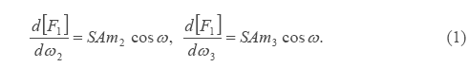
Acknowledgments should be positioned at the end of the paper before the reference section. The text of the acknowledgments is in 11 point font. When referring to citations in the text, in square brackets [ ] show the number in order of appearance. In the reference section, the references themselves are in 10 point size font, single line spacing. List all references in numerical order. Note: figures and tables must be inserted in the text and may not follow the Reference section.

1. M. P. Brown and K. Austin, The New Physique, Publisher, London, 2002, pp. 25-30.

